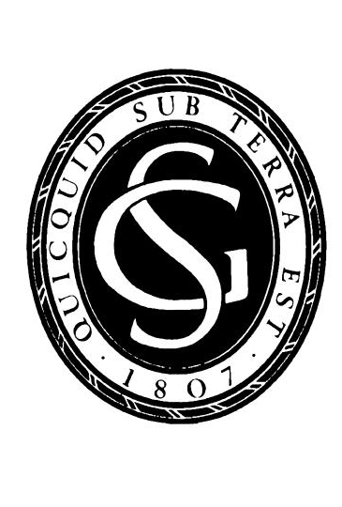


Arthur Holmes Meeting 2015: Tsunami Hazards
and Risks: Using the geological record
FIELD TRIP: 22-24 September 2015
CONFERENCE: 25 September 2015
Registration Form

Personal Details

Title: |  |  | First Name/s:
Surname: |  |  | Organisation:
Address:
Postcode:
Email: |  | Tel No:

Registration Fees

Conference Attendance
25 September 2015
Burlington House, London, UK

GSL/GSJ Member, GSL Associated Society or GSL Corporate Affiliate | £80 |  | Retired | £50
Non-Member | £130 |  | Student | £25

Field Trip Attendance
Registration for the Arthur Holmes Field Trip 2015 has now closed.
22-24 September 2015
The Shetland Islands, UK

Field Trip (Land Only) * | £280 |  | This includes:  - Return Ferry to Yell (from the mainland)  - Transport from hotel to field site  - 1.5 day field trip  - 2 nights bed and breakfast in shared twin room  - Field trip materials  - Food (dinner and lunch etc etc etc)
Additional Supplements:
Return Flight: London Heathrow to Sumburgh, Shetland** | £320 |  | This includes:  - Outward flight (details will be confirmed before the event)  - Return flight (details will be confirmed before the event)  - Return transfer from Sumburgh Airport to the hotel in the Shetlands.
Permanent address: |  |  | Passport no:
 |  |  | D.O.B:
Single Room Occupancy*** | £170 |  | This includes:  - 2 nights single room bed and breakfast

Payment Details
 |  | I enclose a cheque for |  |  | made payable to The Geological Society
 |  | Please debit my Visa/Master/Amex/Switch card
 |  | Card Number: |  |  |  |  |  |  | Issue number if maestro:
 |  | Start Date: |  |  |  |  |  | Expiry Date:
 |  | Security Number (last 3 digits on black strip on back of credit card):
 |  | Cardholders name and address if different from above:

Signature:____________________________________________________ Date: ____________________

General Information
Full prepayment must accompany your registration form to guarantee a place. Student ID will be required. An email confirmation will be sent on receipt of your completed registration form. Notification of cancellation of conference bookings must be given at least 10 working days prior to the event for a refund to be given. Please note: no refund is available for the Field Trip (including all supplements).

We would like to keep you informed about future meetings and other Society activities. Please tick here if you do not want to receive such information

Please return this form to:
Jess Aries
Email: jess.aries@geolsoc.org.uk

Address: Conference Office
Geological Society
Burlington House
Piccadilly
London W1J OBG
UK

